Lab 8
Implementing a IKEv2 VPN on IOS
Objective:
The purpose of this lab is for the student to understand configuration and implement an IKEv2 VPN. Students will utilize the IOS CLI to explore and configure an ISR Router.
Diagram:
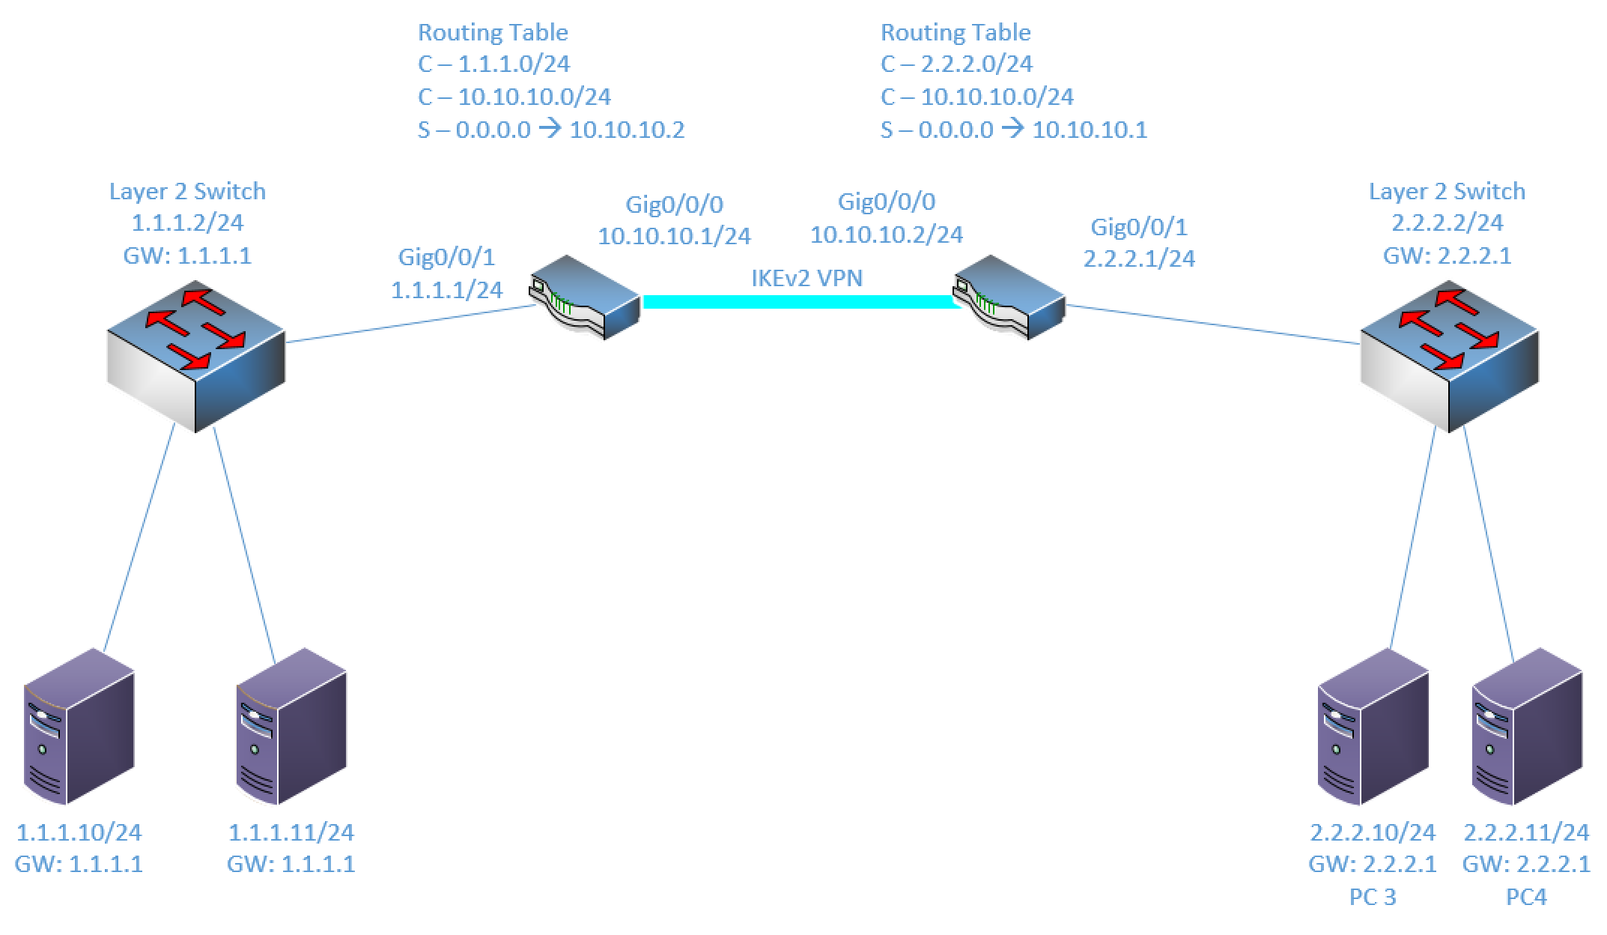
Components:
4 – PCs
2 – Cisco 3650 Layer 2 Switches
2 – Cisco 4321 ISR Routers

Useful commands for this lab

show crypto ikev2 session ! To display the session details
show crypto ikev2 sa detail !To display phase 1 details
show crypto ikev2 profile !To display the IKEv2 profile information
show crypto ipsec sa !To display the IPSec phase 2 details

Procedure:
- Connect all PC’s together on the layer 2 switches and put their static IP addresses, subnet masks and gateways on them. Test connectivity by pinging each machine within the network.
- Configure the IP addresses on the Router’s interfaces and turn on the interfaces.
- Make sure the PCs on the same network can ping each other and their gateway.
- Configure the static default route on each router as shown in the diagram
- Use the supplied configuration to configure Router 1. configure each section separately so you can verify it’s successful before moving on to the next
- Use the configuration from Router 1 to create the configuration for Router 2. You’ll have to remember to change IP addresses and names to be relevant to router 2. Technically the names could be the same, but it’s best practice to change them. For Instance:
  - ROUTER1-PROFILE to ROUTER2-PROFILE
  - ROUTER1-ROUTER2-NACL to ROUTER2-ROUTER1-NACL
- Before you add the configuration to router 2, make sure you change the name and any reference to the name lower in the config. For instance:
  - match address ROUTER1-ROUTER2-NACL to match address ROUTER2-ROUTER1-NACL
- Once your text file is ready for Router 2, paste it in one section at a time so you can confirm that it’s successful. If you have any typos in your names or references to names, you might get an error.
- Once the crypto map is applied on the interfaces on both sides, you should be able to ping from 1.1.1.10 to 2.2.2.10. If not, verify your config and adjust until the configuration is successful.
- Screen shot the VPN details from one of the routers and paste them below. Use the “show” commands provided above to verify your traffic is being encrypted.
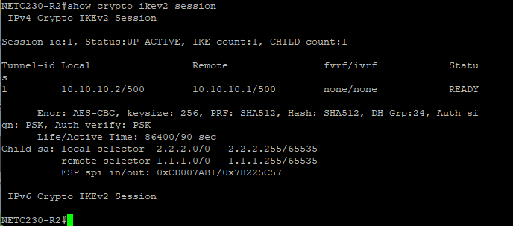
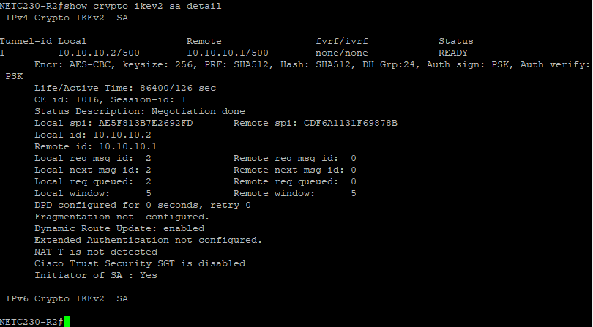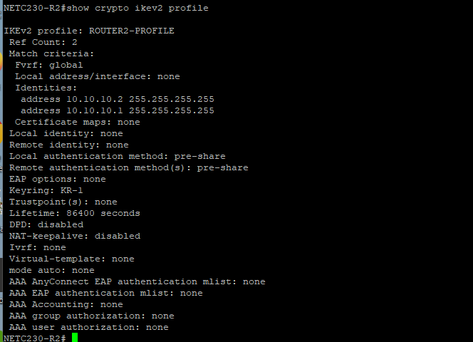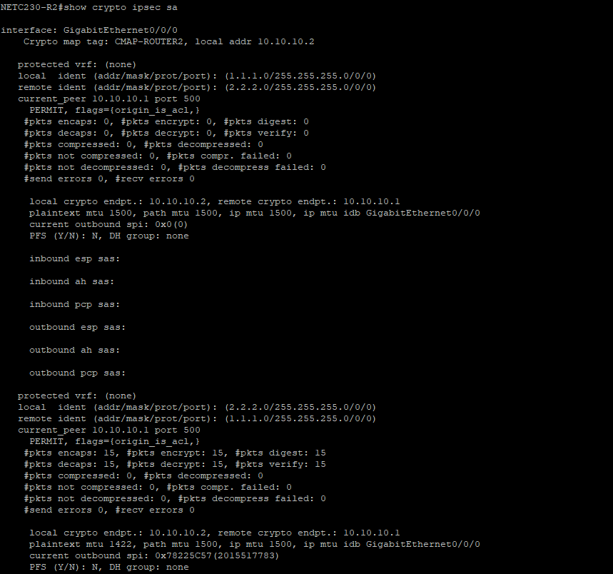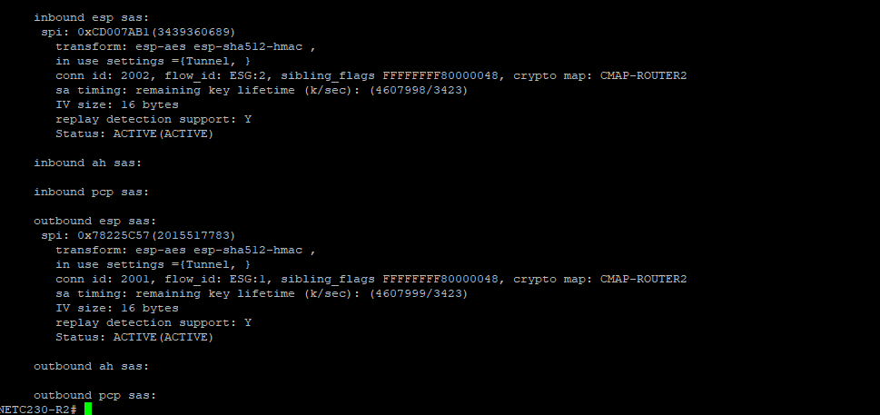
- Draw the lab diagram below (PC’s, router and switch connections) Label the IP addresses, subnet masks, and gateways used by each device. Label the routing tables next to the routers. Label your IKEv2 VPN endpoints.
